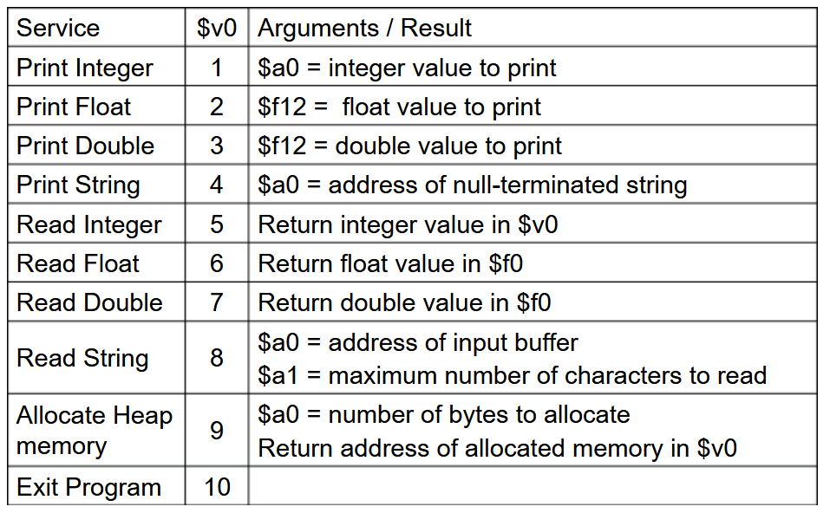

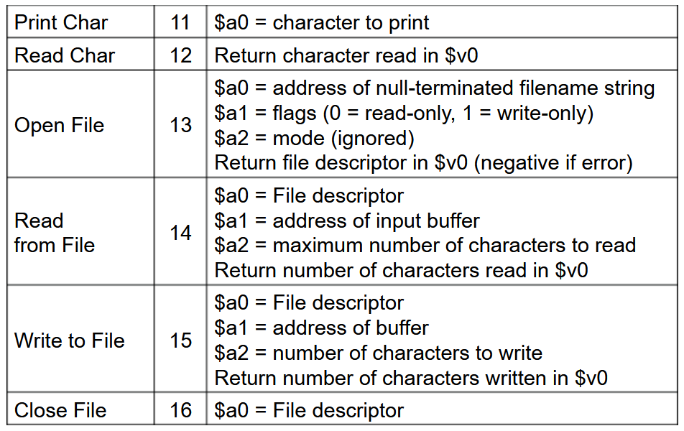

Problem : Write a program in MIPS to find the square of any number using the function.

.data  
     msg1: .asciiz "Enter any number: "            #input message  
     msg2: .asciiz "Square of the number is: "     #output message  
       
.text  
     #input message  
      la $a0,msg1  
      li $v0,4  
      syscall  
       
     #Taking integer input  
      li $v0,5    
      syscall  
      move $t0,$v0  
        
     jal Square   #Jump and Link to Square function  
       
     #Terminating the program  
       li $v0,10  
       syscall  
Square:  
       mul $t1,$t0,$t0  
     
       #Output message  
        la $a0,msg2  
        li $v0,4  
        syscall  
         
       #Printing square of the number  
        move $a0,$t1  
        li $v0,1  
        syscall  
         
       jr $ra

Problem : Write a program in MIPS to swap two numbers using a function.

#swap two number using function

.data

ms1: .asciiz "Enter 1st number: "

ms2: .asciiz "enter 2nd number "

ms3: .asciiz "after swapping 1st number is "

ms4: .asciiz " after swapping 2nd number is "

.text

main:

li $v0, 4

la $a0, ms1

syscall

#taking the input

li $v0,5

syscall

move $s0,$v0

li $v0, 4

la $a0, ms2

syscall

#taking the input

li $v0,5

syscall

move $s1,$v0

jal swap

li $v0, 10

syscall

swap:

add $t1,$zero,$s0

add $s0,$zero,$s1

add $s1,$zero,$t1

li $v0, 4

la $a0, ms3

syscall

li $v0, 1

move $a0,$s0

syscall

li $v0, 4

la $a0, ms4

syscall

li $v0, 1

move $a0,$s1

syscall

jr $ra